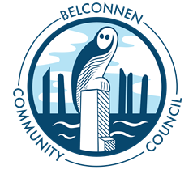

Belconnen Community Council Inc.
Committee Meeting
29 September 2021
7.00pm
https://us06web.zoom.us/j/85868861915
Agenda
Attendance
Apologies
Minute taker

Agenda Item | Notes
1 - Chairs Report
Action Items
 | Moved | Glen Hyde | Seconded | Charles

2 - Treasurers Report
Action Items
 | Moved | Maree Pavloudis | Seconded

3 – Other Reports | Glen Hyde
 | Charles Thomas
 | Clayton Browne
 | Elias Hallaj
 | Maree Pavloudis
 | Allan Hollink
 | Matt Watts
Action Items
 | Moved |  |  | Seconded

4 – Other Business
Action Items
 | Moved |  | Seconded

Correspondence
In
Out
Next Meeting | 7pm Wednesday 27 October 2021
Close

