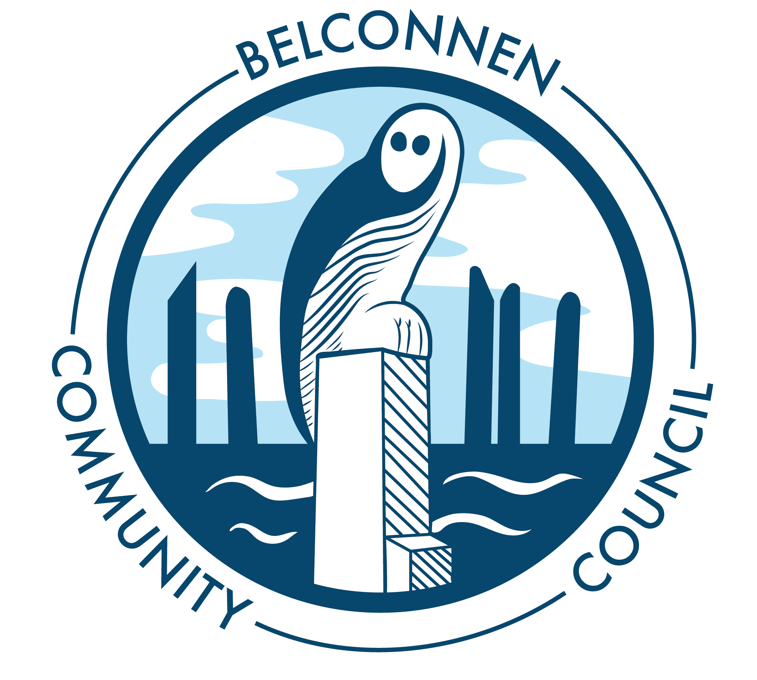

Belconnen Community Council Inc.
Committee and Planning Meeting
30 January 2021
5.00pm
Agenda

Attendance
Maree Pavloudis, Clayton Browne, Mary van der Graaf, Charles Thomas, Glen Hyde

Apologies

Matt Watts

Chairs Report
All quiet on the world of Belco. Three items in other business.

Moved: Glen Seconded: Clayton

Treasurers Report

Moved: Maree Seconded: Mary

Other Reports
Bush on the Boundary in December.
People and Places met 29 Jan to see off Chair and tour of Ginninderry. Funding is environmentally focussed for ACT portion. See change would like to talk to Committee in 2021; we will ask them to present.
GCG on Ginninderra Falls and plastics. We will ask for some info to get the plastics dealt with. Clayton would like to explore Sydney Harbour Sea Bins.

Correspondence
In: Request to present on Canberra Hospital Master Plan
Old Health Centre site
North Lawson
Molonglo River Bridge application

Out: Nil

Other business
Planning for 2021
Call for ideas
Carp bins
Sponsor a carp competition
Banners Maree to send updated option 2 with white lettering for approval and options for table cloths
Charles to check availability for next meeting
Change for signatories to account

Meeting closed at 7.32pm

Next meeting: 7pm Wednesday 24 February 2021 via Zoom

