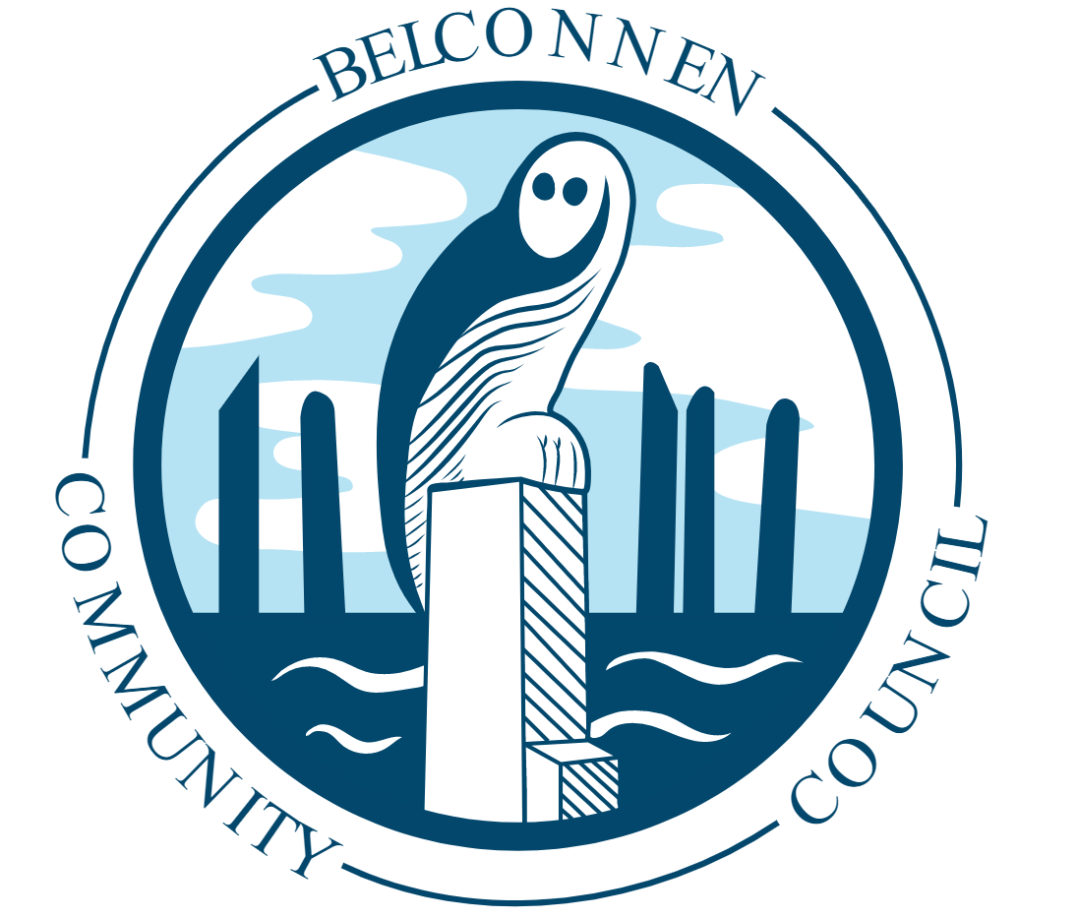

Belconnen Community Council – Chair’s Report March 2020
2020 has brought us a number of challenges in both physical and non-physical ways. After the significant recovery effort put into our disastrous bushfire season by governments, business and the many volunteers across our community, we are now faced with an invisible invader where the only defence is good hygiene practices and social distancing. In my lifetime, this is the greatest risk our global community has faced; I have been fortunate not to witness the pure evil of war and the loss of countless lives that goes with it. But this war against COVID-19 is one we can win through following the instructions and guidance of our health officials and professionals, by using good sense and being kind to each other. There are many people around us who cannot and do not have the capacity to protect and care for themselves in the same way so many of us take for granted; we need to be vigilant, aware of their needs and sensible in how we think, act and behave. We all owe each other a duty of care and we have a proud tradition in this district of looking out for each other and meeting those challenges with good grace.
It is for those reasons we have taken the extraordinary step of moving all our public meetings online. Effective immediately, those meetings will be conducted over the internet (on our Facebook page) and there will be no access to a physical meeting room for the community until further notice. While we understand the need to be able to have face to face discussions, given our current advice and our general duty of care to the community we have taken this action to minimise the spread of COVID-19.
But all other activities will continue unless the advice changes, so please continue to engage with us in the usual ways and via email at chair@belcouncil.org.au and hello@belcouncil.org.au .

I wanted to take some time to recognise the efforts of the UC Canberra Capitals and their choice to bring the grand final match back to Belconnen. We are proud of the role the team plays in our community and the role models they have become to many in this district; our support for them is just as important as the sponsorship provided by our University of Canberra. While there is some talk about the state of the AIS Arena and the precinct more generally, bringing the big games to Belconnen makes sense for a number of reasons, not just fan capacity.
There is some talk around the traps that we are about to lose the AIS in its current form; that on top of a push by the Chief Minister to build a replacement stadium in the City would be devastating for our local economy, businesses who service this precinct and our community more generally. The stadium and the AIS Arena are desperately in need of refurbishment; there’s no question of that. But to steal our sporting and entertainment hub away from this district makes no economic or structural sense; we have the public transport infrastructure, the dirt carparks can be upgraded and if, as many suspect, there is a push for more housing in the precinct then a mixed use development can be proposed through the usual channels. There is little we can do if Sport Australia decide to abandon the precinct; that will be a decision made outside of our jurisdiction. But we deserve to keep this important infrastructure in our district. Period. If that changes then we expected to be fully consulted on any proposals and changes to this important part of our community.

In the coming weeks with every challenge we will face, please remember to be kind to each other and look out for those who are vulnerable and in need. We are best when we work together.

Glen Hyde
Chair
Belconnen Community Council

